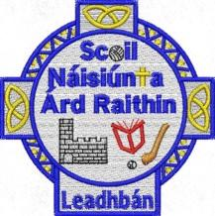
June 2026
Dear Parents,
The school has purchased and labelled all books and copies for your children in line with Department guidelines again this year.
There is therefore no need for you to purchase any books or copies for your child and no booklists will be issued.
Please see below the list of stationery your child will need in their pencil cases for the coming year.
Fifth Class
- Bic red & blue pens
- Pencils & (one for the compass)
- Maths Set containing compass, protractor, small ruler
- Colouring pencils
- 30cm ruler
- Calculator
- Large Pritt Stick
- Highlighter
- USB

Sport:
- Gum shield
- Hurl
- Helmet
- Boots

Please ensure that all stationery is clearly labelled with your child’s name.

