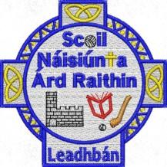
June 2026
Dear Parents,
The school has purchased and labelled all books and copies for your children in line with Department guidelines again this year.
There is therefore no need for you to purchase any books or copies for your child and no booklists will be issued.
Please see below the list of stationery your child will need in their pencil cases for the coming year.
Fourth Class
Pencil Case:
- 3 pencils
- Topper
- Rubber
- 3 Bic red pens
- 3 Bic blue pens
- Colouring pencils/twistables
- 2 x 43g Large Pritt Stick (labelled)
- 30cm ruler
- 2 x black whiteboard markers (labelled)
Sport:
- Gum shield
- Hurl
- Helmet
- Boots

Please ensure that all pencils, pens, erasers, toppers and colours are clearly labelled with your child’s name.

