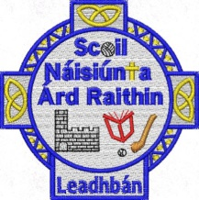
4/6/2024
Dear Parents,
The school has purchased and labelled all books and copies for your children in line with Department guidelines again this year.
There is therefore no need for you to purchase any books or copies for your child and no booklists will be issued.
We ask that you supply your own child’s stationery as our book grant did not extend that far.
Please see below the list of stationery your child will need in their pencil cases for the coming year.

First Class
- 3 thin triangular shaped pencils
- Eraser
- Pencil Sharpener
- Red Pen
- 30cm Ruler
- 3x Whiteboard pens
- Pritt sticks (x2)
- Colours (no markers or novelty colours)

All items of stationery to be clearly labelled

